**Build a Plasma Donor App with AWS Serverless Computing**

During the COVID 19 crisis, the requirement of plasma became high and the donor count being low. Saving the donor information and helping the need by notifying the current donors would be a helping hand. In regard to the problem faced, an application is to be built which would take the donor details store it and inform them upon a request.

Serverless computing is the current trend of software application development. Micro services are a popular new approach for building maintainable, scalable, cloud-based applications. AWS is the perfect platform for hosting micro-services. In this project we will be building a plasma donor app with AWS services like lambda functions, API gateway and DynamoDB.

**Architecture:**

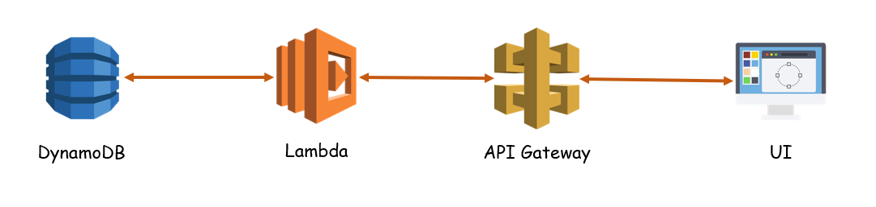

**Learning Outcomes:**

By the end of this project:

* You’ll be able to work DynamoDB, lambda functions and API Gateway.
* Build a flask application which will take the user inputs, update the DynamoDB and notify the user upon request.

**Project Work Flow:**

* User interacts with the application.
* Registers by giving the details as a donor.
* Database will have all the details and if a user posts a request then the concerned blood group donors will get notified about it.

**Tasks:**

1. Required initial steps
2. Sign in to AWS console
3. Create a database
4. Create APIs to

* Push the registration data into database.
* Fetch the data upon login.
* Display the stats of different blood groups.
* Upon request, take the required blood group and return the details

1. Create a flask application

* Registration page
* Login page
* Stats page to display the count
* Request page
* Test it

1. Deploy the application

* Create an EC2 instance.
* Deploy the app.

**Task 1: Required initial steps**

To complete the project successfully, you need to install:

* Python IDE (IDLE / Spyder / PyCharm)
* Python boto3, requests, flask
* AWS Account

**Activity 1:** Install Python IDE (Spyder/ PyCharm IDE is Ideal to complete this project)

To install **Spyder IDE**, please refer to: [Spyder IDE Installation Steps](https://www.youtube.com/watch?v=ou65T_mC8Z8)

To install **PyCharm IDE**, please refer to: [PyCharm IDE Installation steps](https://www.youtube.com/watch?v=YxHplztMQMc)

**Activity 2:** Install python packages

If you are using **anaconda navigator**, follow below steps to download boto3, requests and flask:

* Open anaconda prompt as administrator.
* Type "pip install flask” and click enter.
* Type "pip install boto3” and click enter.
* Type "pip install requests” and click enter.

the above steps allow you to install the packages in the anaconda environment

If you are using any other **IDLE**please follow below steps to install boto3, requests and flask:

* Open Command Prompt.
* Type "pip install flask” and click enter.
* Type "pip install boto3” and click enter.
* Type "pip install requests” and click enter.

the above steps allow you to install boto3, requests and flask.

For reference [Click here](https://www.youtube.com/watch?v=tiTud_BlozA)

**Activity 3:** AWS Account Creation

If you are a student graduating from any of the colleges and have an institution mail ID, you'll be eligible to get the **AWS Educate account**. This is the preferred way as you need not give the credit card information to create the account. To create AWS educate account follow the steps on [this page](https://idre.ucla.edu/signing-up-for-a-ucla-aws-educate-account). Scroll down completely to get the steps to be followed by a student.

If you are not a student or don't have an institution mail ID, then you need to create a personal account by giving the credit card information. To create an AWS account follow the steps on [this page](https://aws.amazon.com/premiumsupport/knowledge-center/create-and-activate-aws-account/).

**Task 2: Sign in to AWS console**

1. **AWS Educate Account**
2. Sign in with your credentials: <https://www.awseducate.com/signin/SiteLogin>
3. Click on AWS Account, which you can find in the top right corner.
4. Click on AWS Educate Starter Account
5. You'll be redirected to vocareumlabs page, click on AWS Console button.
6. The console will be launched.
7. **AWS Account (Personal)**
8. Open <https://aws.amazon.com/console>
9. Click on "Sign In to the Console" button.
10. Choose the root user and give your credentials.
11. You'll be redirected to the console.

**Task 3: Create a database**

**Activity 1:** Create a table in DynamoDB

**Step 1:** Under services in AWS Console, search for “DynamoDB” and open it > click on “Create table”.

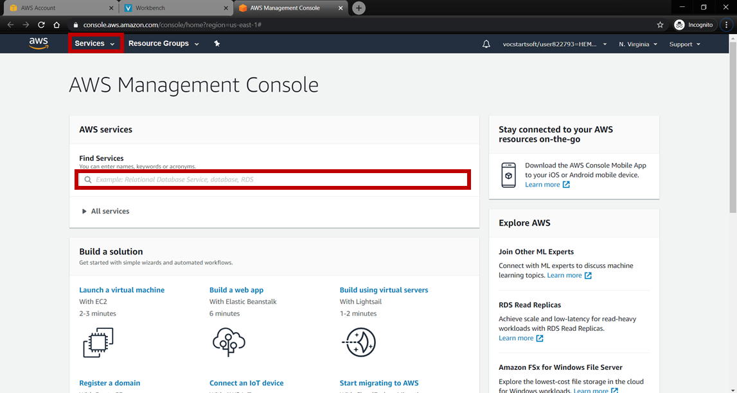

**Step 2:** Give the table name (users) and the primary/partition key as email. We will be storing the users’ data using email as the primary key. After clicking on create the table will be created.

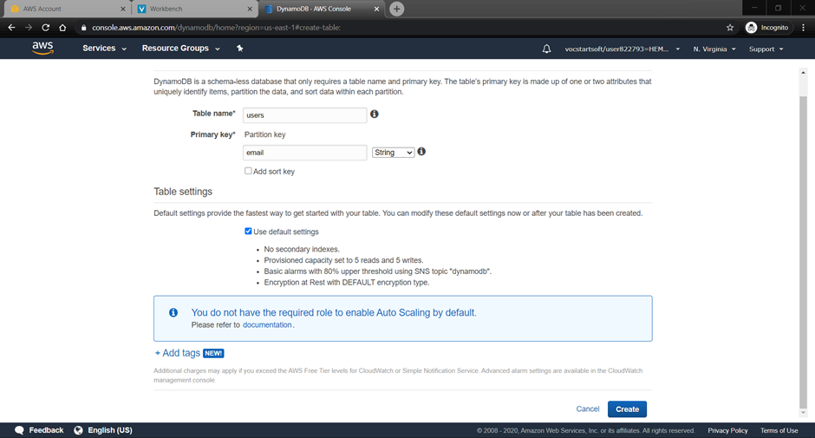

**Task 4: Create lambda functions and APIs**

**Activity 1:** Create a lambda function for registration data (To push the data which user entered while registration into DynamoDB)

**Step 1:** Under services in AWS Console, search for “lambda” and open it > click on “Create function”.

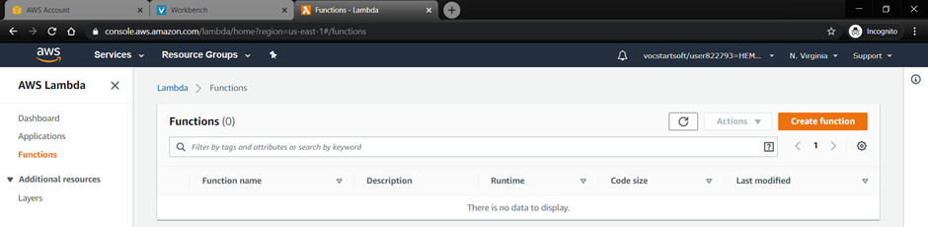

**Step 2:** Choose “Author from Scratch” > name the function (registration) > choose “Python 3.6” > click on create function

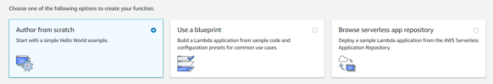

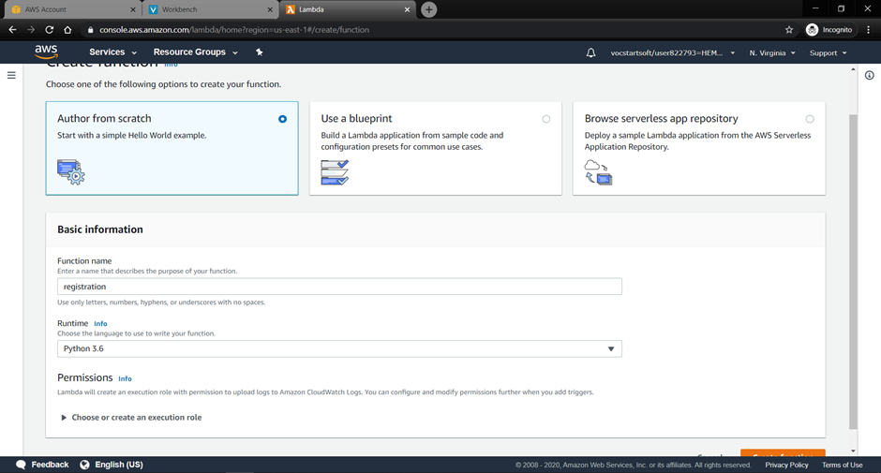

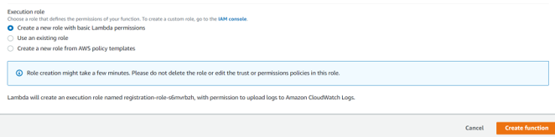

**Step 3:** Scroll down and write the below code in the function.

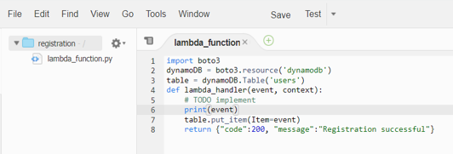

**Activity 2:** Attach the policies to the role created: To access the DynamoDB using lambda function the permissions are to be given. To attach the policy open IAM from services.

**Step 1:** Choose roles

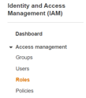

**Step 2:** Choose the role which was created while creating the lambda function.

(Hint: The role name will be similar to the lambda function name)

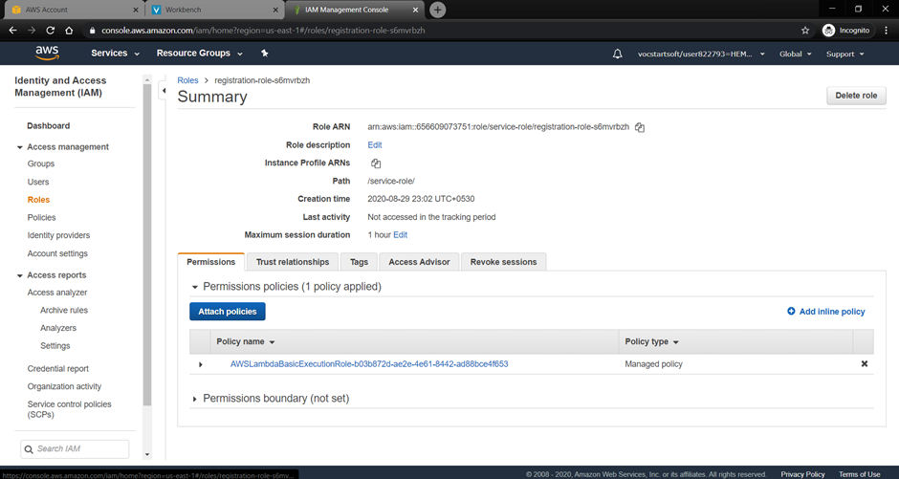

**Step 3:** Click on Attach policies > search for “dynamodb” > choose the fullaccess policy > click on Attach policy

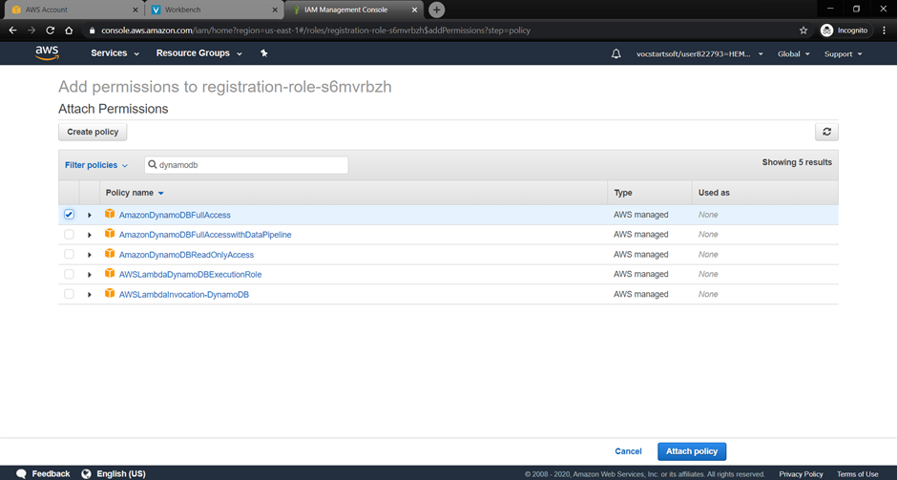

**Activity 3:** Test the lambda function

**Step 1:** Open the lambda function created > click on Test (you can find it on the top right corner or in the middle of the page).

**Step 2:** Give the event name / test case name. Give the sample input > click on create

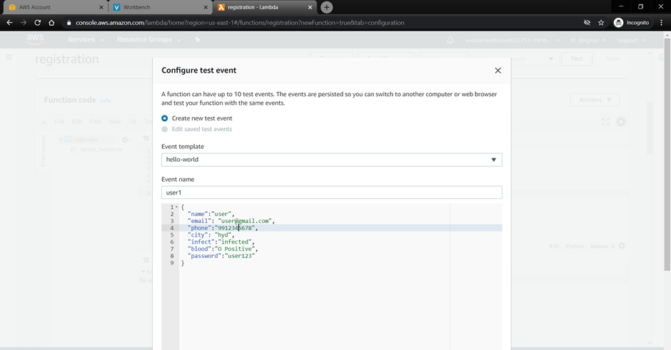

**Step 3:** After the test event is saved, click on test to test the lambda function

The result should be “Registration successful”, if the function is executed and the data is pushed to the database.

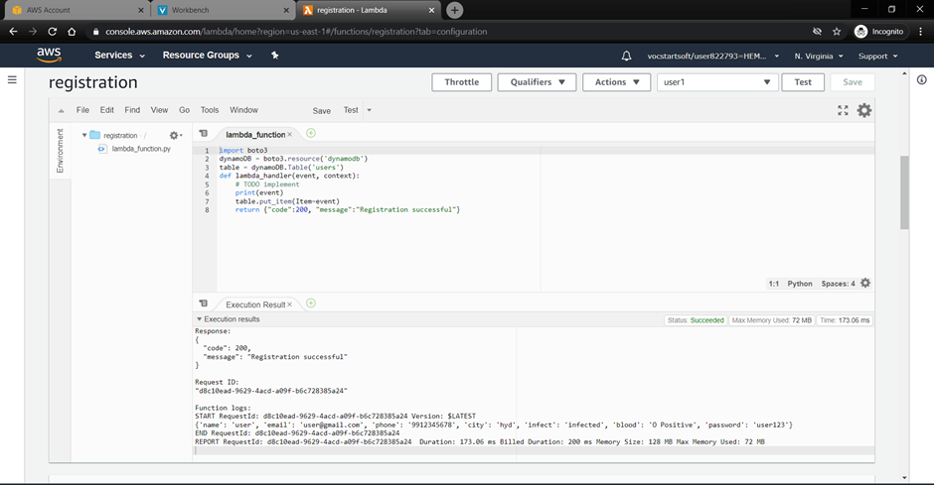

**Step 4:** Open the database to check if the data is inserted.

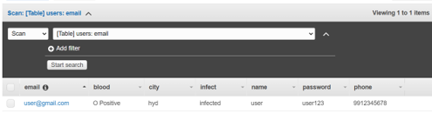

**Activity 4:** Create an API for the registration lambda function

**Step 1:** Open “API Gateway” from the services from AWS Console.

**Step 2:** Click on “Create API” > choose “REST API” > click on Build under Rest API

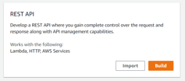

**Step 3:** Choose the REST Protocol > choose “New API” > give a name to it (plasmaApp) > the endpoint type should be “Regional” > click on Create API

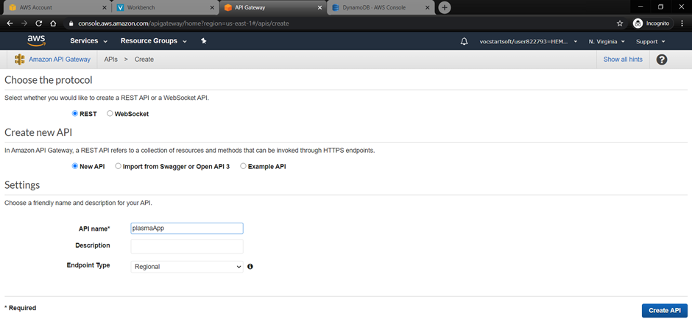

**Step 4:** After the API is created, we need to create a resource under which a method will be created. Click on Actions dropdown and choose “Create Resource”.

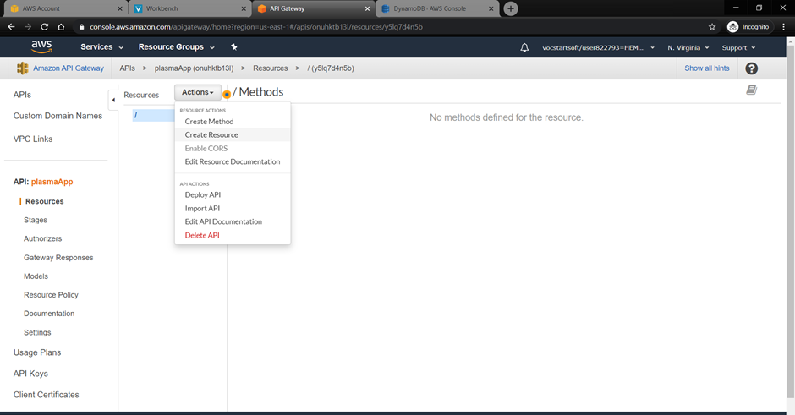

**Step 5:** Give the resource name (registration) > click on “Create Resource”

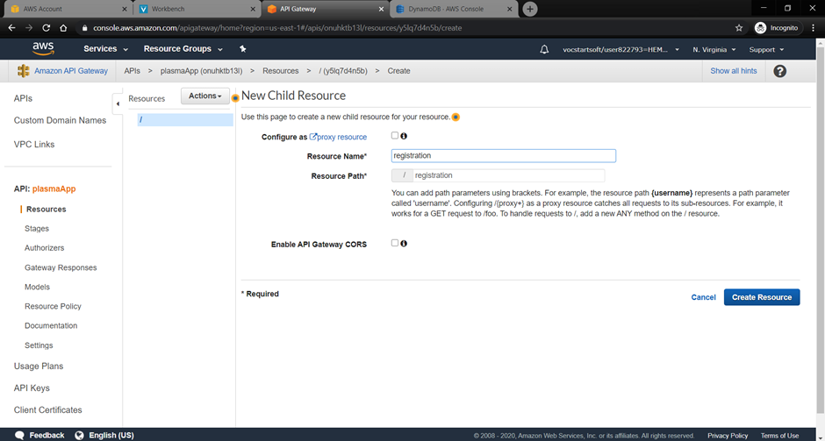

**Step 6:** Under the resource create a method by clicking the actions dropdown > choose GET method > tick the ✔

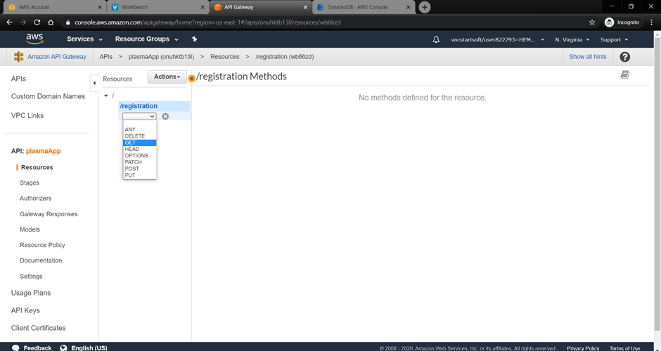

**Step 7:** We shall connect the lambda function that is created earlier to the method. Under the Lambda Function input field choose the lambda function created (registration) > change the default timeout to 1000ms > click on save.

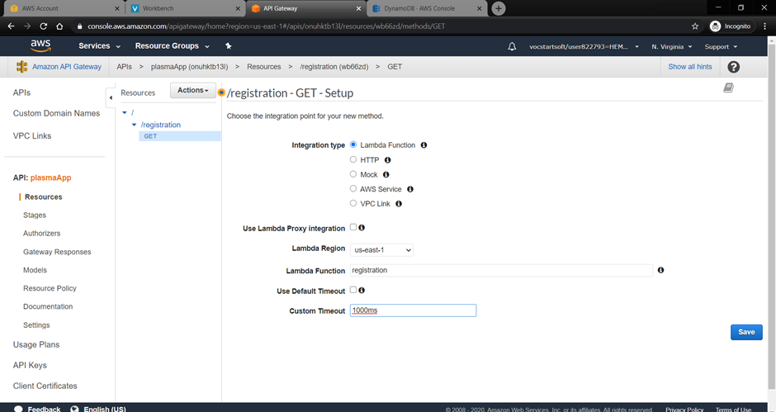

**Step 8:** For GET method the query parameters are to be set to take the specified inputs through URL. Click on Method Request (first box)

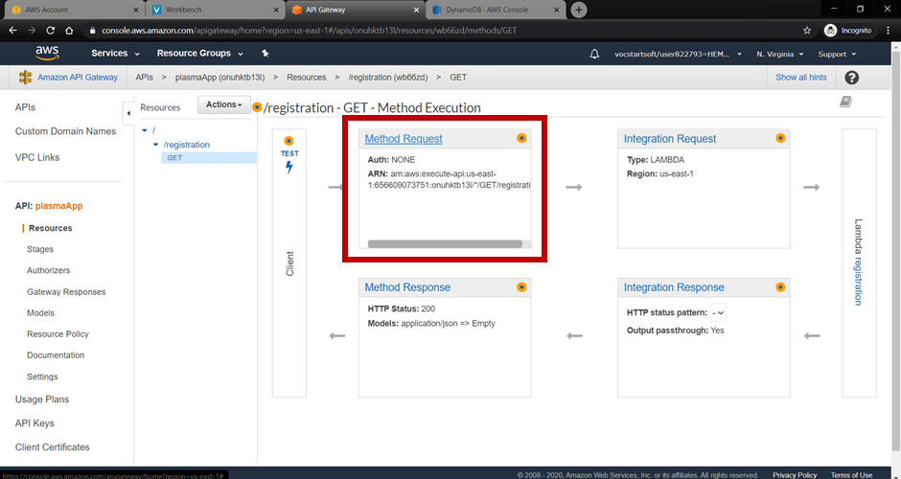

**Step 9:** Give all the input variables by adding the query string. Go back after all are added.

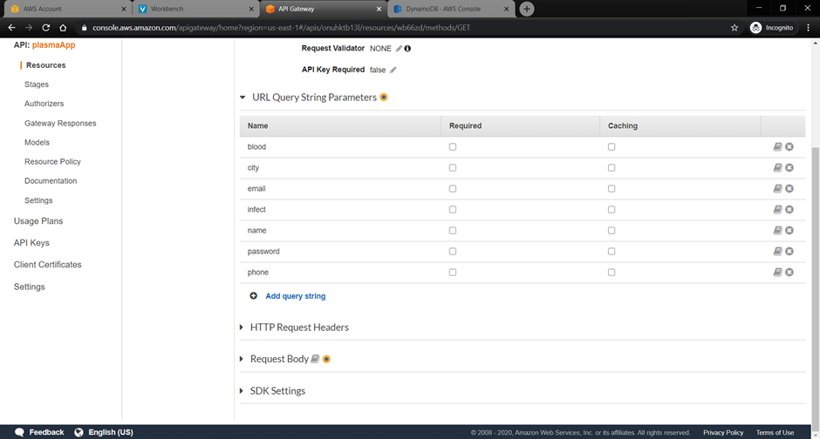

**Step 10:** The URL need to accept the data and send the data in json format. To change the response format, click on Integration request (second box)

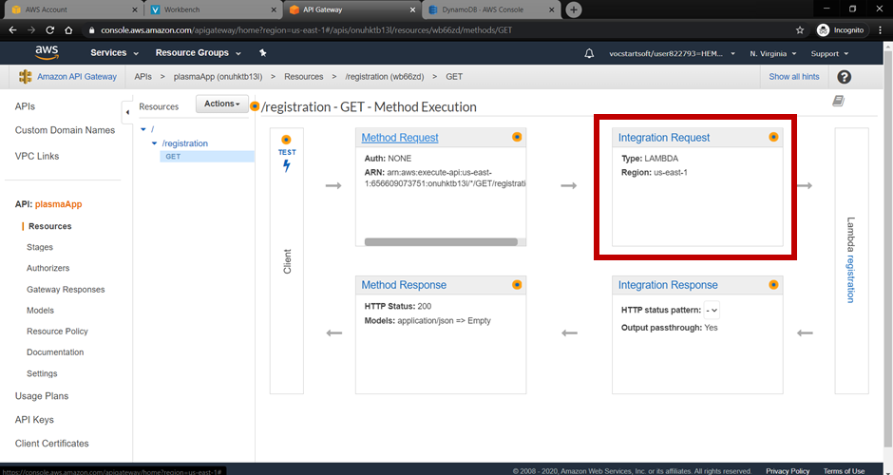

**Step 11:** Scroll down to find the “Mapping templates” > in “Content-type” type application/json and click on tick to get the text box > type the below code > click on Save

**Code:** {

“name”: “$input.params(‘name’)”,

“email”: “$input.params(‘email’)”,

“phone”: “$input.params(‘phone’)”,

“city”: “$input.params(‘city’)”,

“infect”: “$input.params(‘infect’)”,

“blood”: “$input.params(‘blood’)”,

“password”: “$input.params(‘password’)”

}

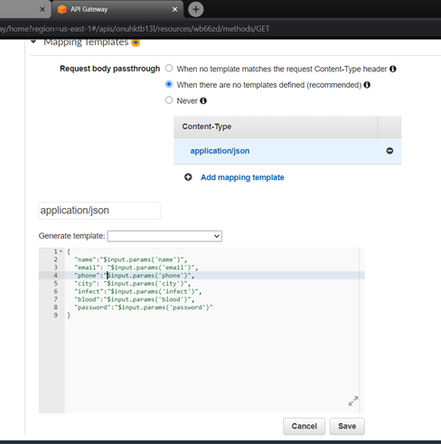

**Step 12:** Go back and click on Test

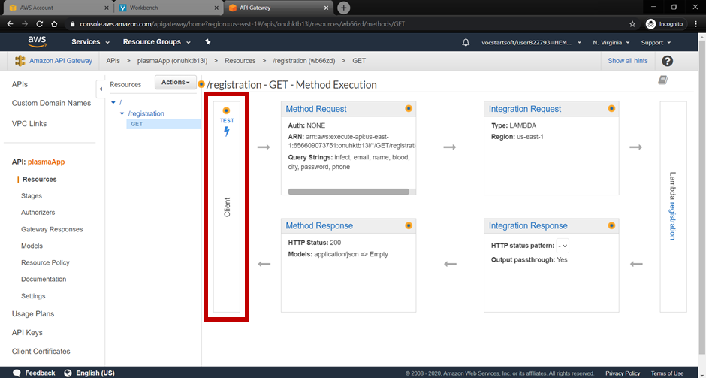

**Step 13:** Give the inputs in {registration} to the method to get the output in the format name=Nidhi&email=nidhi@gmail.com&phone=9123456789&city=Hyd&infect=infected&blood=O Positive&password=nidhi > click on Test > the output will be displayed towards right.

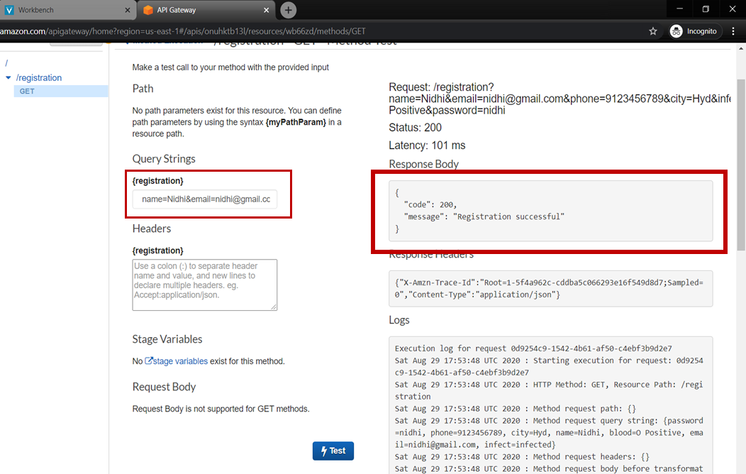

**Activity 5:** Create a lambda function to get the user data based on email, when user tries to login (for authentication).

**Step 1:** Under services in AWS Console, search for “lambda” and open it > click on “Create function”.

**Step 2:** Choose “Author from Scratch” > name the function(getData) > choose “Python 3.6”

**Step 3:** Expand the “Choose or create an execution role” section and select “Use an existing role” > in the drop down select the role which was created with the first lambda function(registration) > click on create function

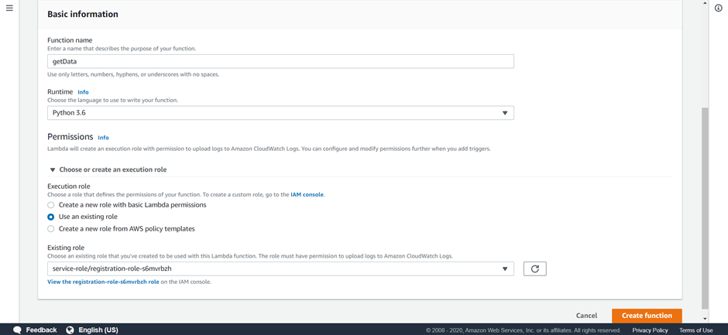

**Step 4:** Scroll down and write the below code in the function. The function takes email as input and returns the data that is pushed into the database.

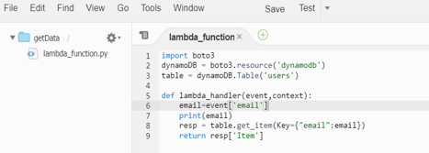

**Step 5:** Save > Test > Give the event name / test case name > Give the sample input > click on create.

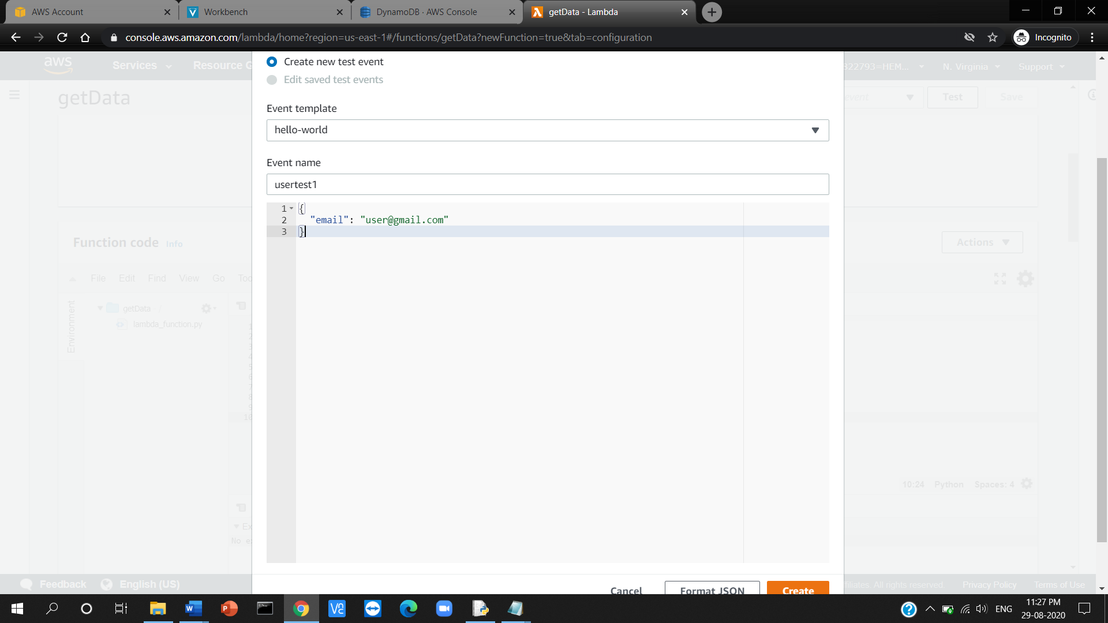

**Step 6:** After the test event is saved, click on test to test the lambda function > you can view the data of the user with given email.

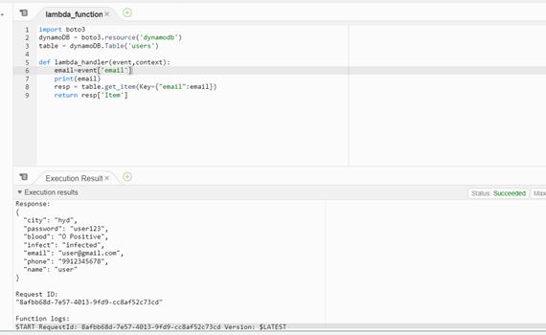

**Step 7:** Open API Gateway > under the created API (plasmaApp) > click on / > under actions create a resource

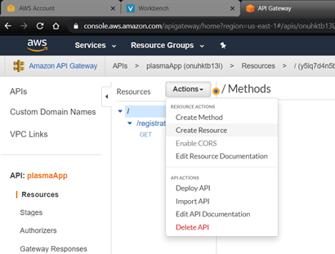

**Step 8:** Give the resource name (getData) > click on “Create Resource”

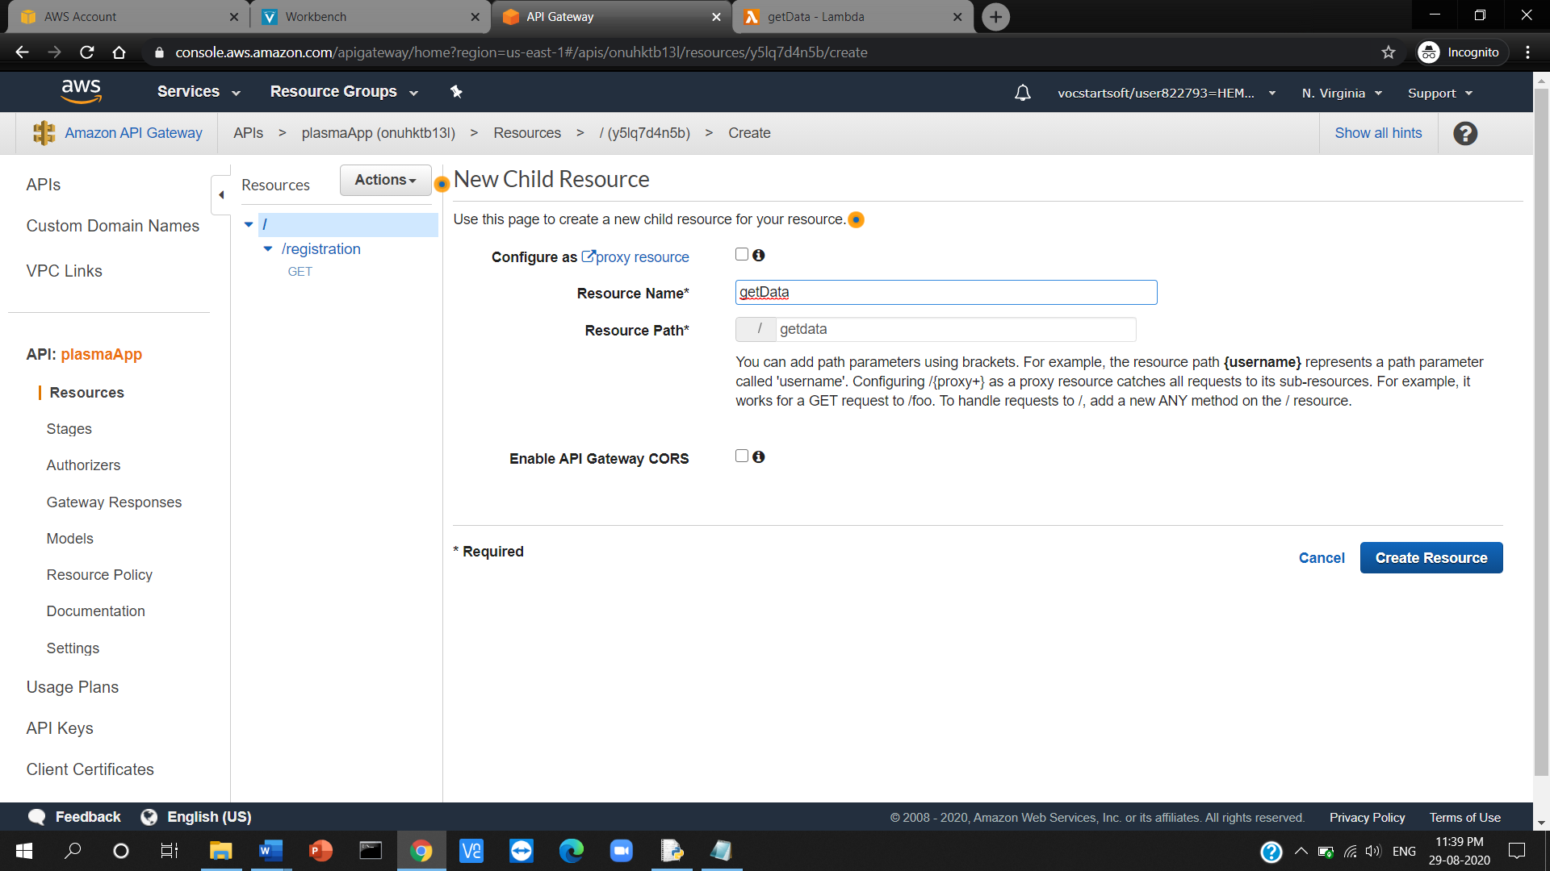

**Step 9:** Under the resource create a method by clicking the actions dropdown > choose GET method > tick the ✔

**Step 10:** We shall connect the lambda function that is created earlier to the method. Under the Lambda Function input field choose the lambda function created (getData) > change the default timeout to 1000ms > click on save.

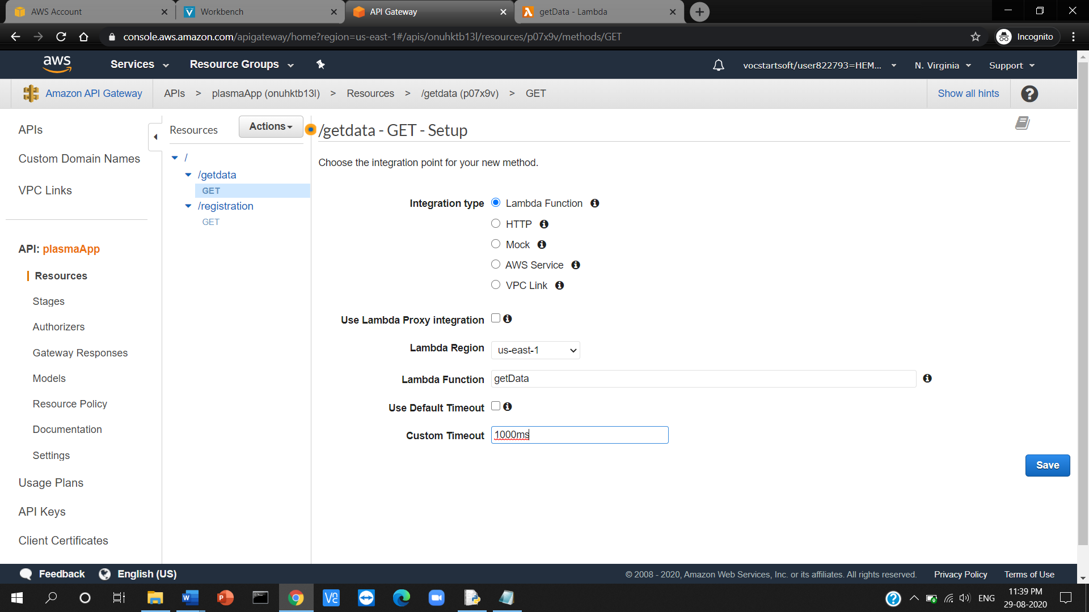

**Step 11:** For GET method the query parameters are to be set to take the specified inputs through URL. Click on Method Request (first box)

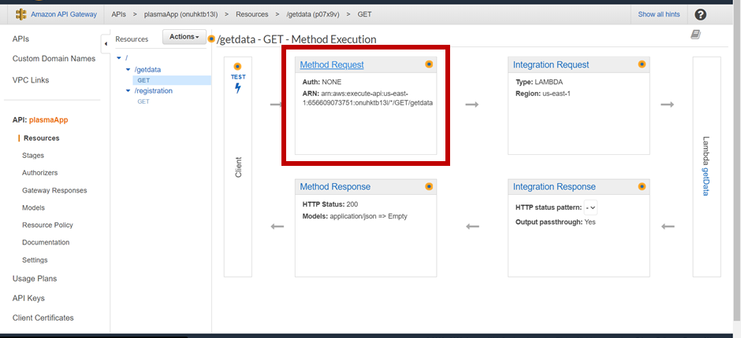

**Step 12:** Give the input variable (email) by adding the query string. Go back

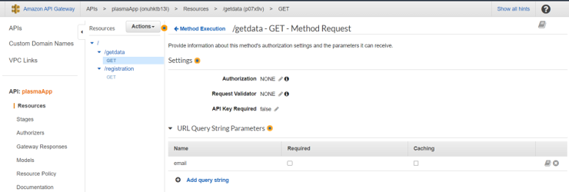

**Step 13:** The URL need to accept the data and send the data in json format. To change the response format, click on Integration request (second box)

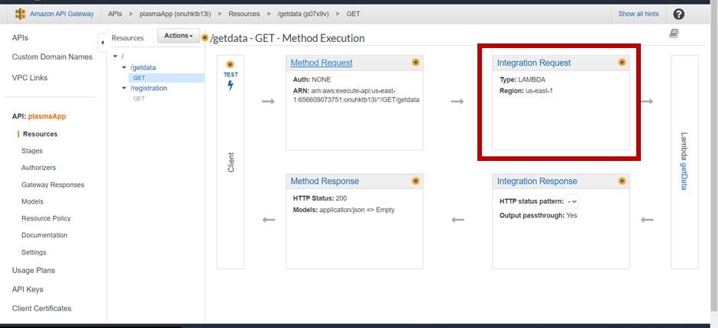

**Step 14:** Scroll down to find the “Mapping templates” > in “Content-type” type application/json and click on tick to get the text box > type the below code > click on Save

**Code:** {

“email”: “$input.params(‘email’)”

}

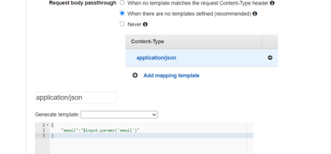

**Step 15:** Go back and click on Test

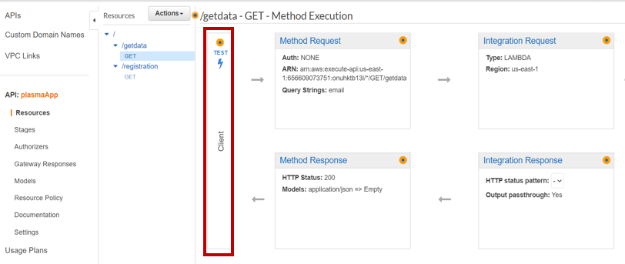

**Step 16:** Give the inputs in {getdata} to the method to get the output in the format [email=user@gmail.com](mailto:email=user@gmail.com) > click on Test > the output will be displayed towards right.

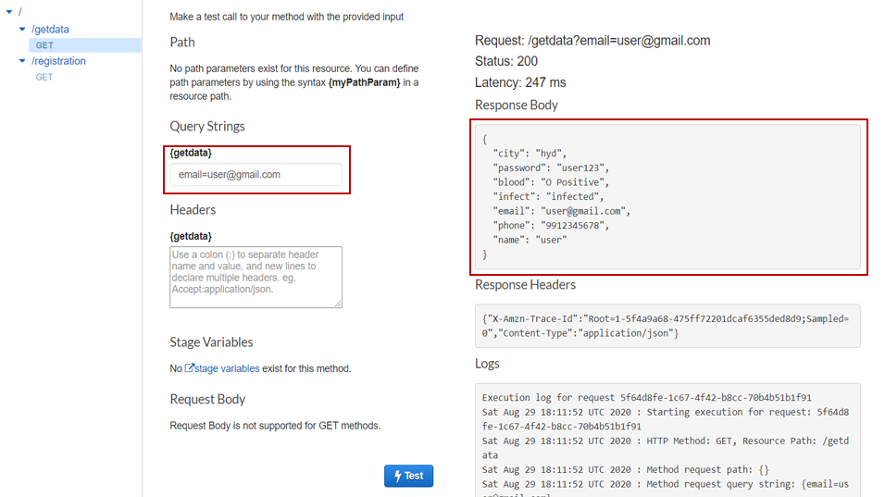

**Activity 6:** Create a lambda function to get the count of the donors who have registered in the application according to the blood groups.

**Step 1:** Under services in AWS Console, search for “lambda” and open it > click on “Create function”.

**Step 2:** Choose “Author from Scratch” > name the function (countOfBloodGroups) > choose “Python 3.6”

**Step 3:** Expand the “Choose or create an execution role” section and select “Use an existing role” > in the drop down select the role which was created with the first lambda function(registration) > click on create function

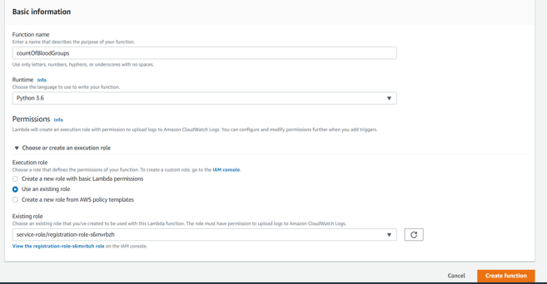

**Step 4:** Scroll down and write the below code in the function. The function passes each blood group as input to DB and returns the count of the number of users who belong one particular blood group and appends into a list, which will be returned at the end.

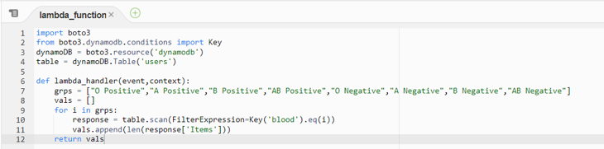

**Step 5:** Save > Test > Give the event name / test case name > Give the sample input > click on create. Input will be empty as we are not externally giving inputs but lambda is considering all bold groups.

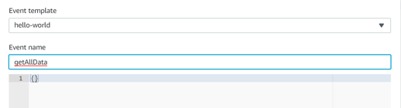

**Step 6:** After the test event is saved, click on test to test the lambda function > you can view the list of count of people for each blood group.

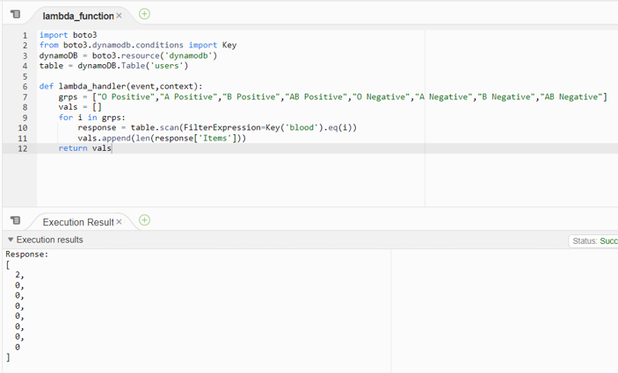

**Step 7:** Open API Gateway > under the created API (plasmaApp) > click on / > under actions create a resource

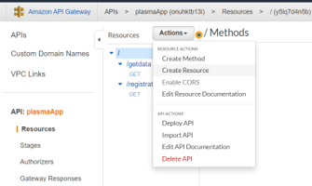

**Step 8:** Give the resource name (getBloodGroupsData) > click on “Create Resource”

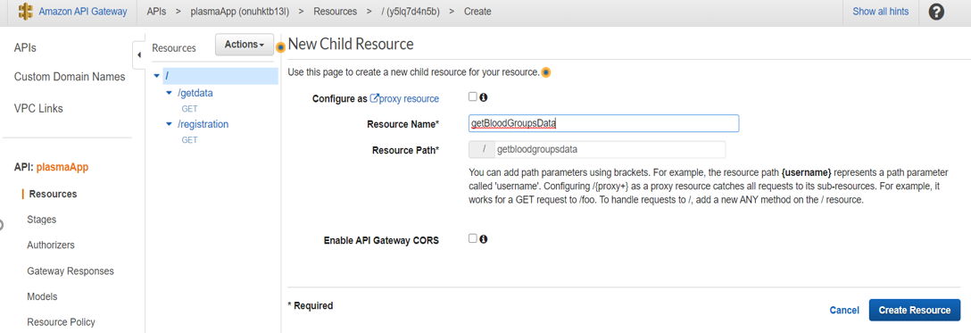

**Step 9:** Under the resource create a method by clicking the actions dropdown > choose GET method > tick the ✔

**Step 10:** We shall connect the lambda function that is created earlier to the method. Under the Lambda Function input field choose the lambda function created (countOfBloodGroups) > change the default timeout to 1000ms > click on save.

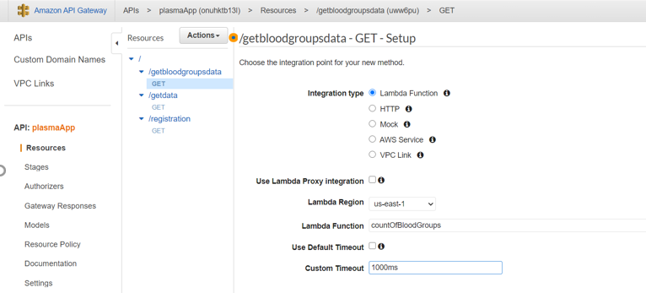

**Step 11:** Click on Test

**Step 12:** We need not specify any inputs > click on Test > the output will be displayed towards right.

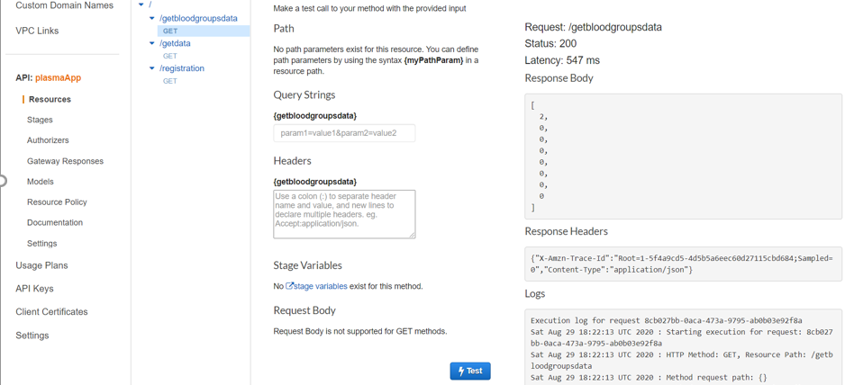

**Activity 7:** Create a lambda function to return the data of users of one particular blood group which is requested.

**Step 1:** Under services in AWS Console, search for “lambda” and open it > click on “Create function”.

**Step 2:** Choose “Author from Scratch” > name the function > choose “Python 3.6”

**Step 3:** Expand the “Choose or create an execution role” section and select “Use an existing role” > in the drop down select the role which was created with the first lambda function(registration) > click on create function

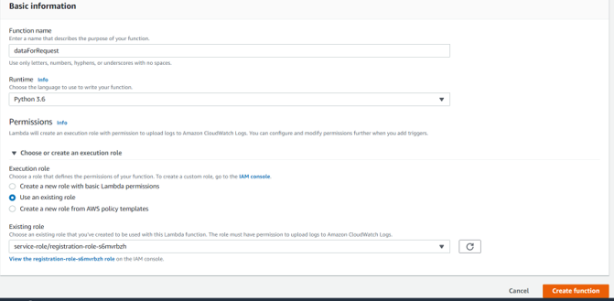

**Step 4:** Scroll down and write the below code in the function. The function takes email as input and returns the data that is pushed into the database.

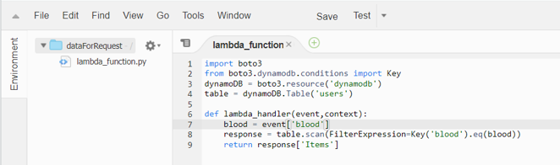

**Step 5:** Save > Test > Give the event name / test case name > Give the sample input > click on create.

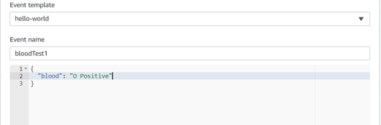

**Step 6:** After the test event is saved, click on test to test the lambda function > you can view the data of people belonging to “O Positive” blood group.

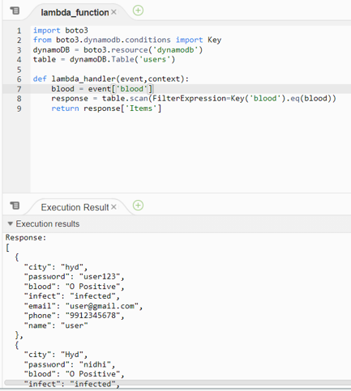

**Step 7:** Open API Gateway > under the created API (plasmaApp) > click on / > under actions create a resource

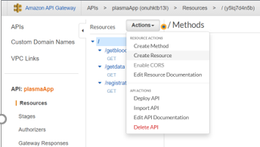

**Step 8:** Give the resource name (requestOnBloodGroup) > click on “Create Resource”

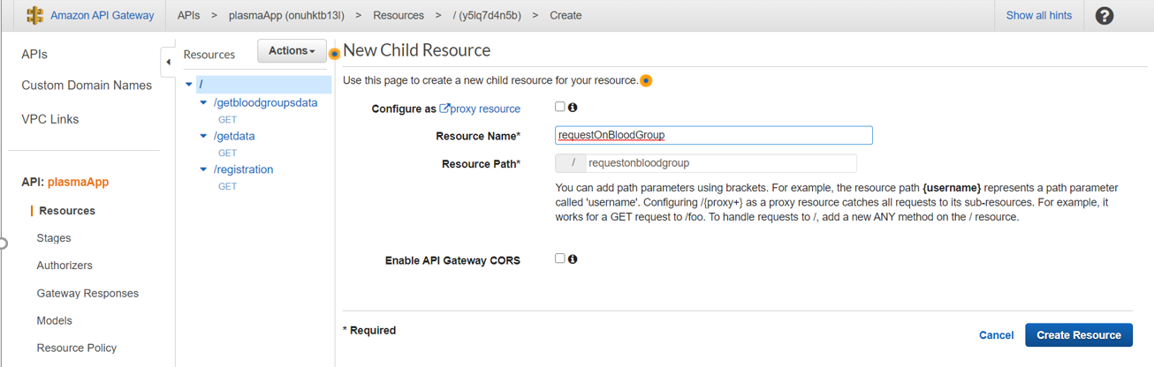

**Step 9:** Under the resource create a method by clicking the actions dropdown > choose GET method > tick the ✔

**Step 10:** We shall connect the lambda function that is created earlier to the method. Under the Lambda Function input field choose the lambda function created (dataForRequest) > change the default timeout to 1000ms > click on save.

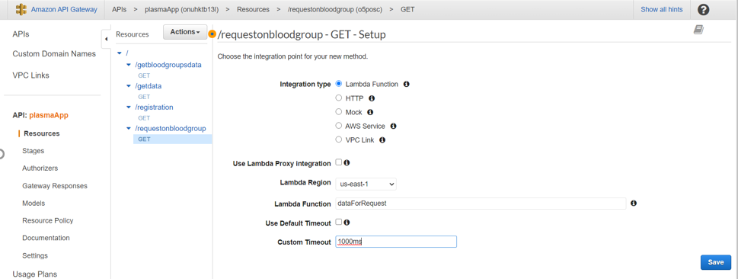

**Step 11:** For GET method the query parameters are to be set to take the specified inputs through URL. Click on Method Request (first box)

**Step 12:** Give the input variable (blood) by adding the query string. Go back

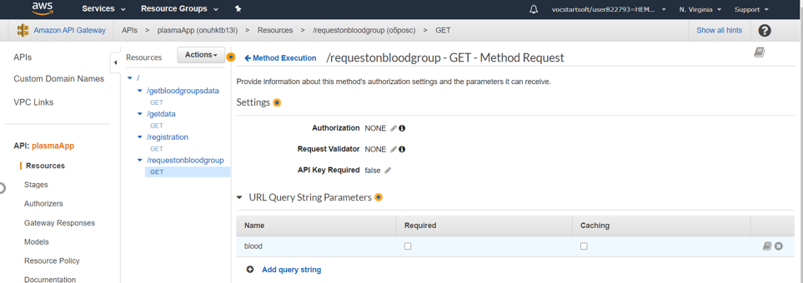

**Step 13:** The URL need to accept the data and send the data in json format. To change the response format, click on Integration request (second box)

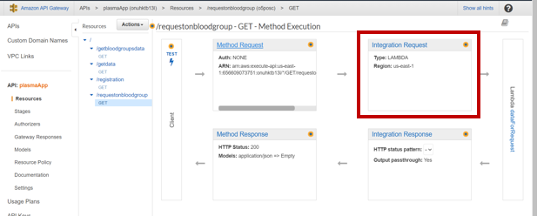

**Step 14:** Scroll down to find the “Mapping templates” > in “Content-type” type application/json and click on tick to get the text box > type the below code > click on Save

**Code:** {

“blood”: “$input.params(‘blood’)”

}

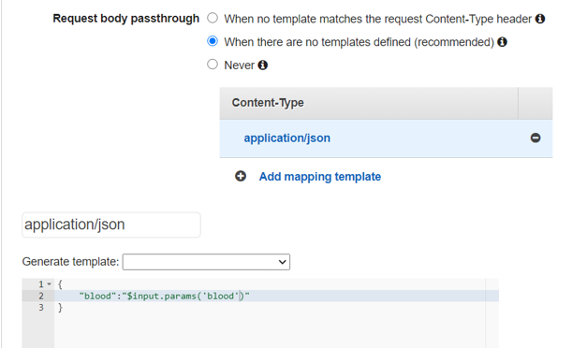

**Step 15:** Go back and click on Test

**Step 16:** Give the inputs in {requestonbloodgroup} to the method to get the output in the format blood=O Positive > click on Test > the output will be displayed towards right.

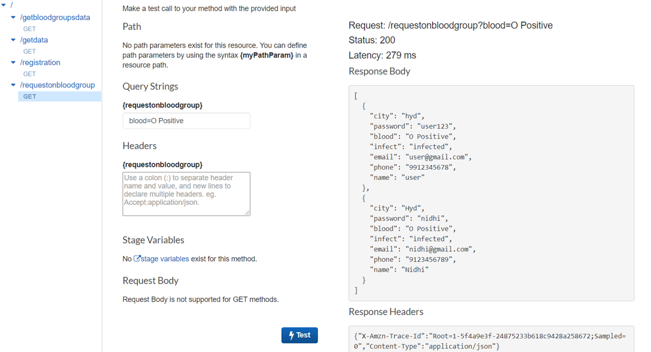

**Activity 8:** Deploy the API

**Step 1:** Under action choose “Deploy API”

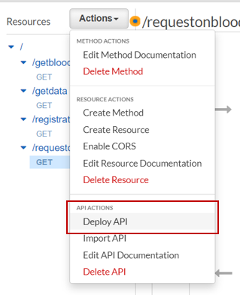

**Step 2:** Under Deployment stage choose [New Stage], name the stage (plasma) > click on deploy. You’ll be redirected to stages.

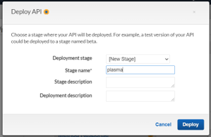

**Step 3:** When you choose the any method under resource you can find the API on screen, which we will be using in future.



**Task 5: Create a flask application**

**Activity 1:** Flask application

**Step 1:** Download the project file from: link

**Step 2:** The file structure should be

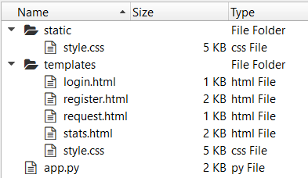

* app.py has the main flask code, which on execution, the application will run.
* templates folder will have the html pages for each operation.
* static folder will have the style sheets

**Step 3:** Replace the existing URL (only till ?), with the API created for getdata.

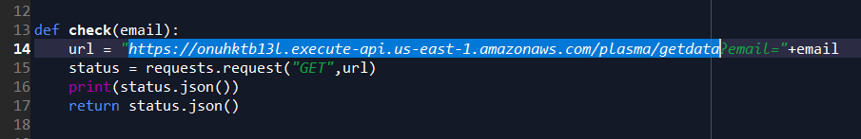

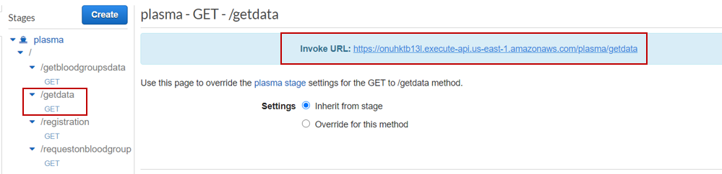

**Step 4:** Replace the existing URL (only till ?), with the API created for registration.

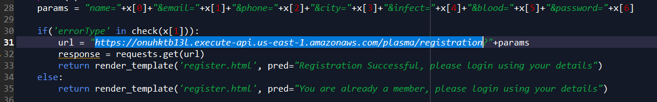

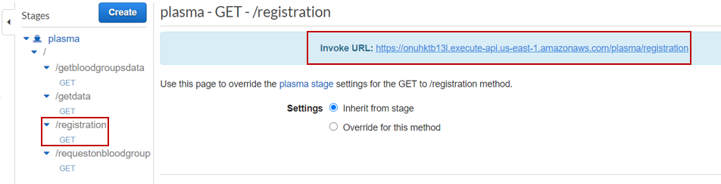

**Step 5:** Replace the existing URL, with the API created to get the count.

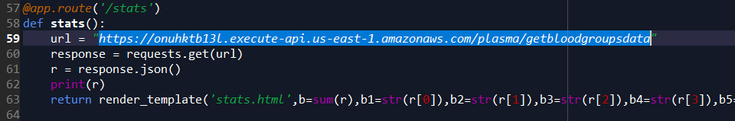

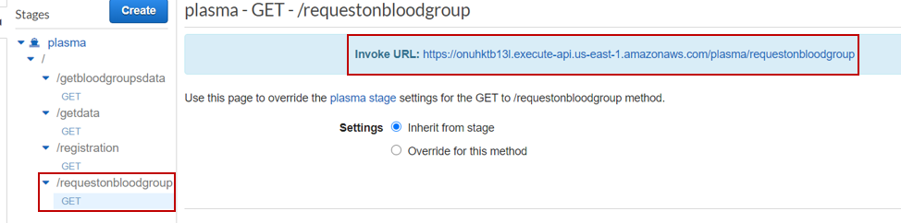

**Step 6:** Replace the existing URL (only till ?), with the API created to get the user data upon request for a particular blood group.

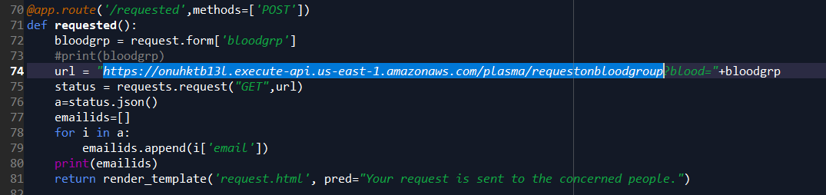

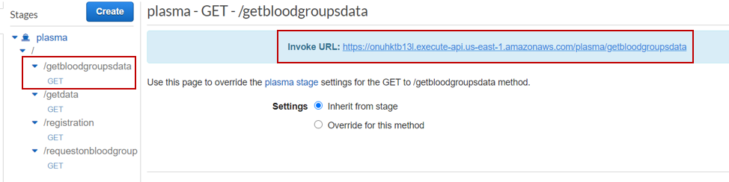

**Activity 2:** Test the application

**Step 1:** Open anaconda navigator if you are using anaconda environment. Open command prompt if you are using other environments like IDLE, PyCharm.

**Step 2:** Navigate to the folder in which you have the file (set the path in prompt)

**Step 3:** Execute main.py using python command

**Command:** python app.py

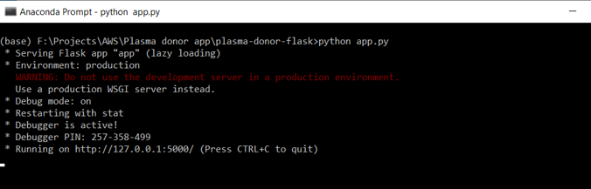

**Step 4:** While file is running, open the browser and launch localhost:5000 to view the application.

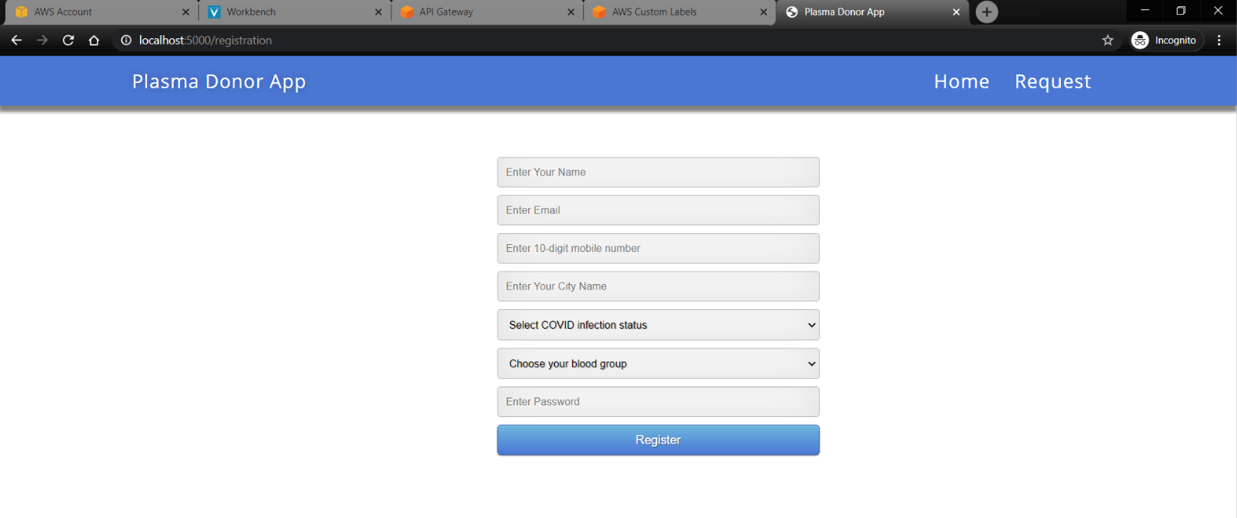

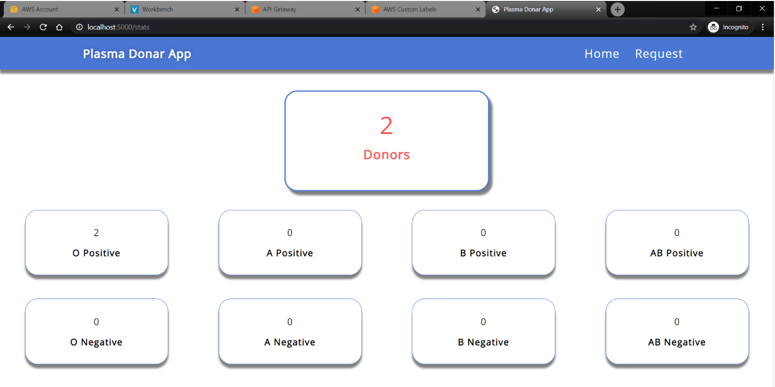

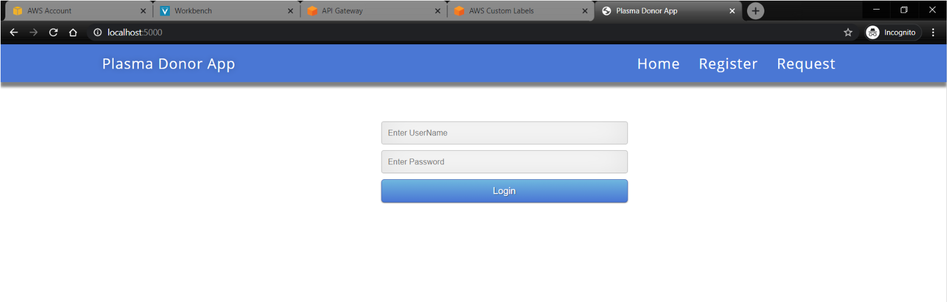

You can check if the database is getting updated with the current values.

**Task 6: Deploy the application using EC2**

**Activity 1:** Create an EC2 instance

**Step 1:** Under services in AWS Console, search for “EC2” and open it > click on “Instances” (you can find it in the left pane).

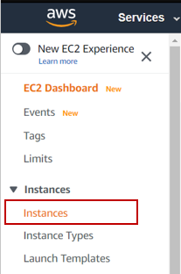

**Step 2:** Click on “Launch Instance”

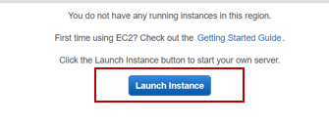

**Step 3:** Select the ubuntu server 18.04 > click on select by letting the 64-bit radio button selected.

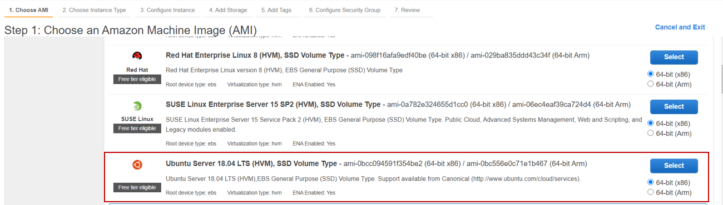

**Step 4:** By default the t2.micro will be selected, check it and click on “Next”

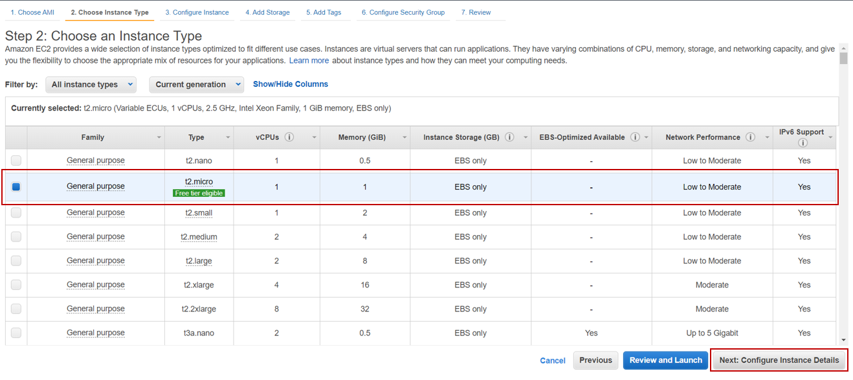

**Step 5:** Click Next > Next > Next > Next. You’ll land up in 6th step (Configure Security Group)

**Step 6:** While setting the required ports, make sure you follow according to the given image below > click on Review and Launch

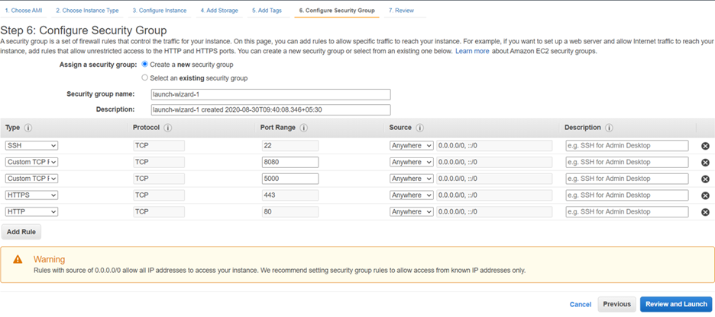

**Step 7:** Click on Launch

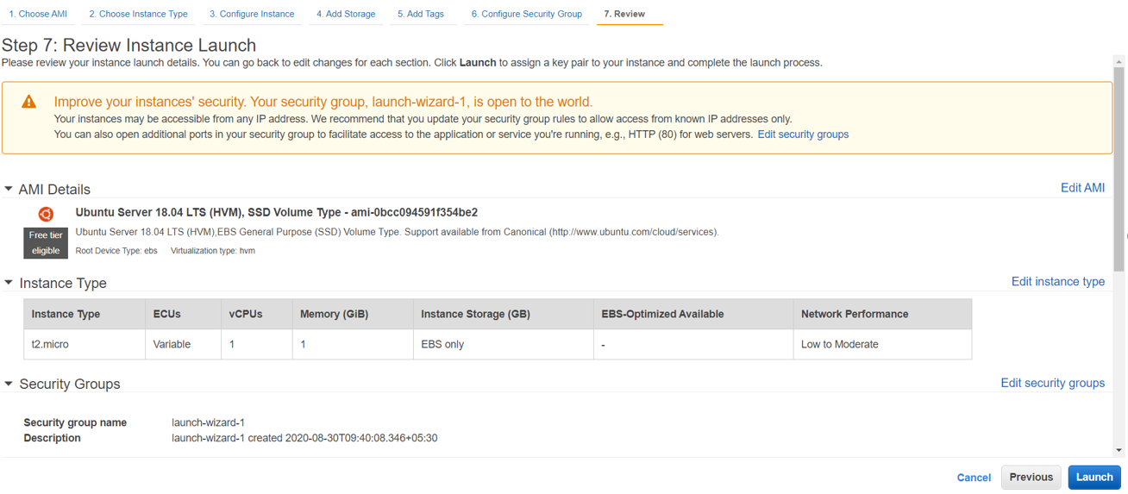

**Step 8:** It’ll ask you select a key pair. This key pair will be used to launch the virtual machine (ubuntu instance created). Choose “Create a new key pair” > give the key pair name (plasmaapp) > click on “Download Key Pair”.

**Note:** The downloaded .pem file (key pair), should be in the C drive (C:/users/username). If it is present in some other location, change the location of the file. Do not rename the file.

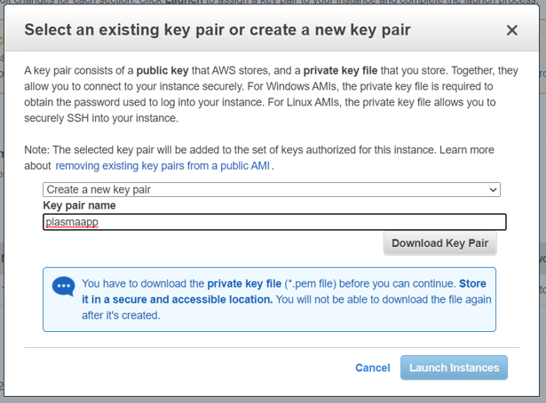

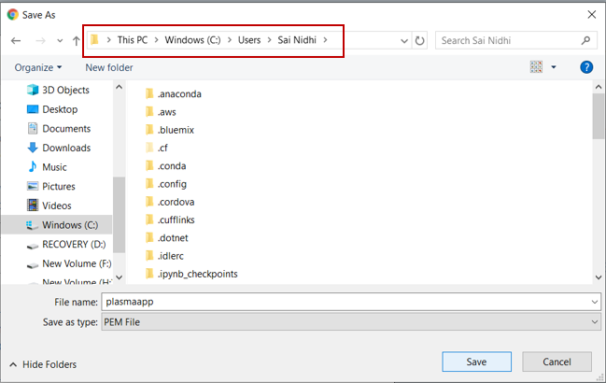

**Step 9:** After the file is downloaded click on Launch Instances. When the instance is launching, click on the link given.

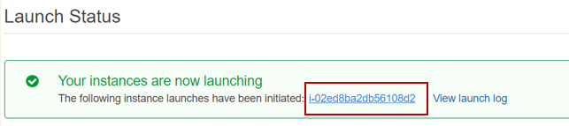

**Step 10:** When the instance status is running > click on Connect

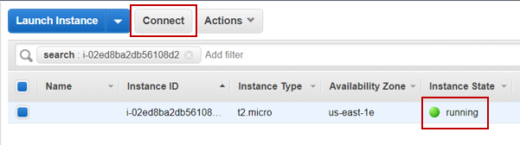

**Step 11:** Copy the link which is present under example and paste it in command prompt > when asked type “yes”

**Note:** If SSH is not present in the system, you need to install putty and then run the instance.

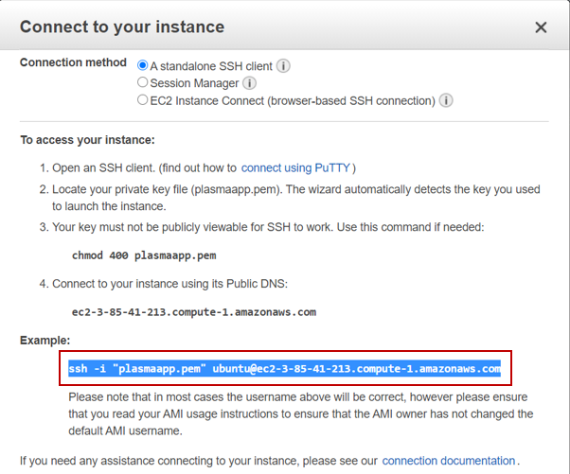

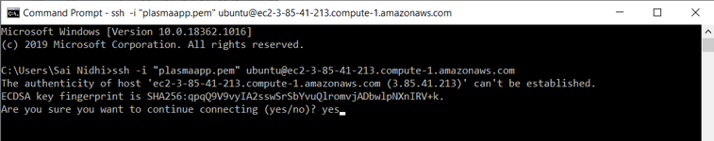

**Step 12:** If you get the screen as the below image, your virtual machine is launched.

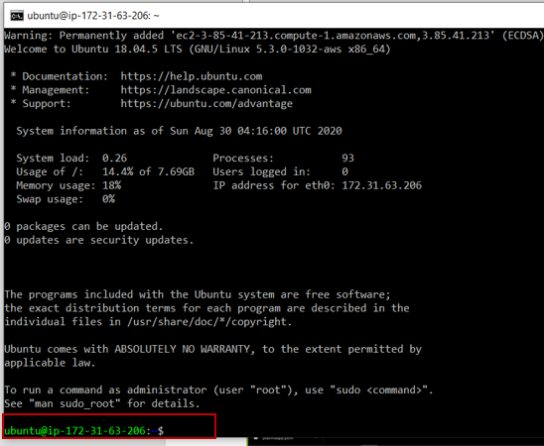

**Activity 2:** Deploy the app

**Step 1:** To deploy the flask application execute the below commands:

sudo apt-get update

sudo apt-get install apache2

sudo apt-get install libapache2-mod-wsgi

sudo apt-get install python3-pip

sudo pip3 install flask

sudo pip3 install requests

sudo pip3 install boto3

sudo apt-get install -y unzip

**Step 2:** After all the required installations are done, clone the application.

**Note:** Upload your application to GitHub and clone it in your virtual machine

**Command:** git clone link



**Step 3:** Give the command ls to know the file name

**Step 4:** Navigate into that folder

**Command:** cd filename

**Step 5:** Unzip the zipped folder present

**Command:** unzip filename.zip



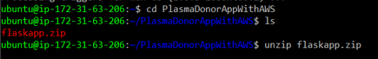

After unzipping the folder



**Step 6:** Link the folder to the site-root defined in apache’s configuration (/var/www/html) by default.

**Command:** sudo ln -sT ~/foldername /var/www/html/foldername



**Step 7:** Open the folder from /var/www/html/foldername > delete the existing zip file

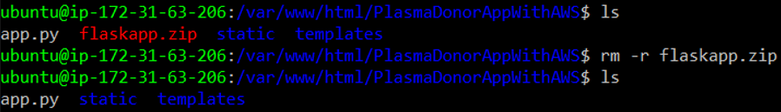

**Command to remove a folder:** rm -r filename.zip

**Step 8:** Run the python file (application)

**Command:** python3 app.py

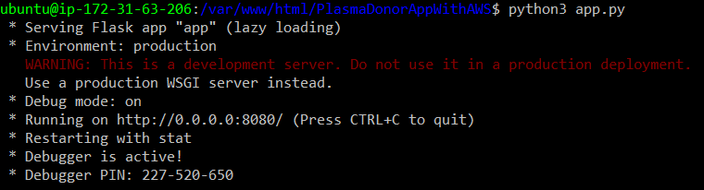

**Step 9:** Copy the public DNS. You can find it in the instances.

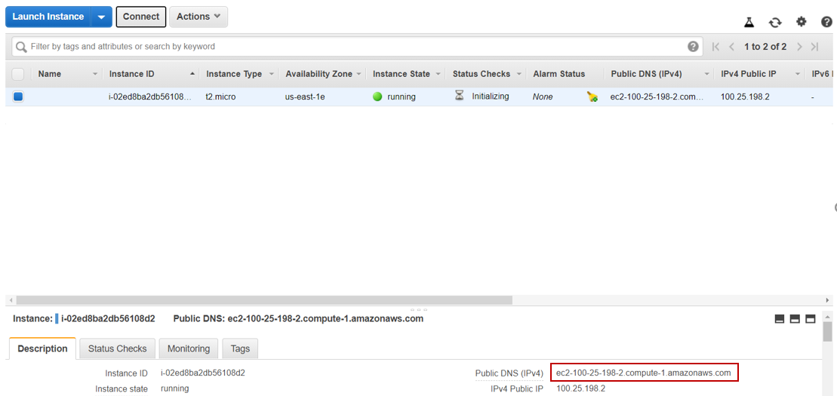

**Step 10:** Open the browser > paste the DNS copied > append the URL with :8080 (port number specified in the flask application) > application will be launched



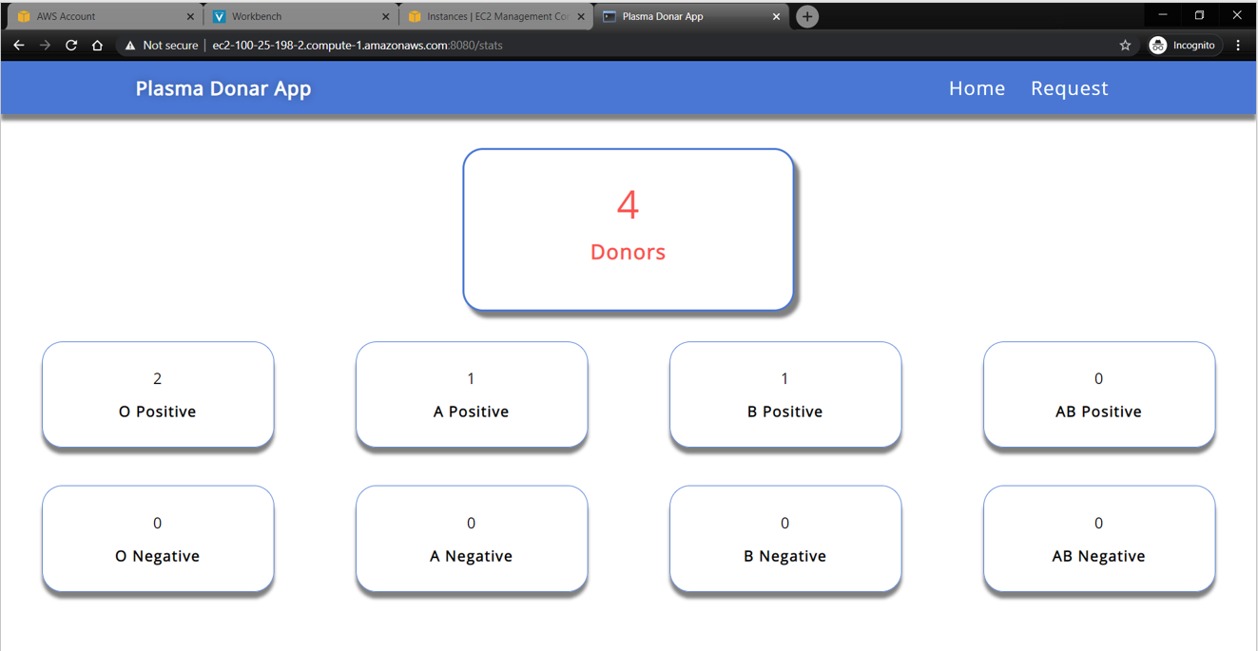

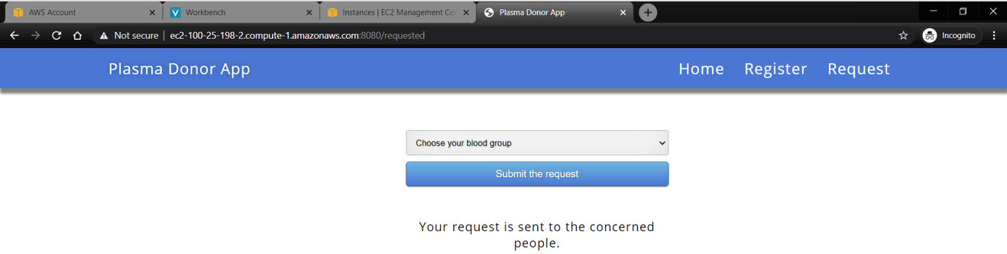

**Important things to be noted while using AWS Cloud:**

* AWS Cloud is pay-as-you-use service.
* To avoid extra billing or loss of credits, make sure you stop the instances that are running when not in use.
* To stop the flask application that is running, give the command ctrl+c.
* To stop the instance of EC2, go to instances > choose your instance > under Actions dropdown > Instance State > Stop

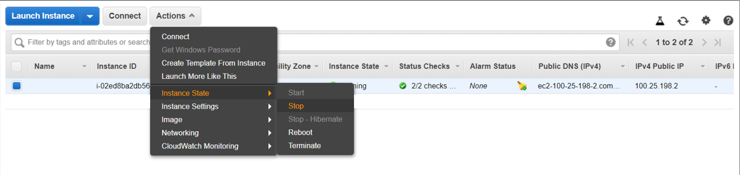

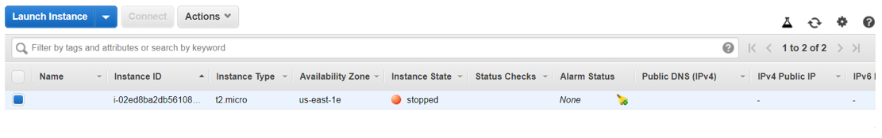

* To start it follow the previous step and click on start.
* Logout from the console when not in use. Do not leave the console logged in if not in use.
* Keep checking the billing page frequently to measure the extra billing in your account.